ADVANCING RARE‑EARTH TECHNOLOGIES FOR THE ENERGY TRANSITION, DIGITAL INDUSTRIES, AND HIGH‑VALUE MATERIALS
А.I. Ivanov¹, V.N. Petrov¹, А.V. Jonson^{1,2}
¹ GIREDMET, JSC Moscow, Russia
² National Research Technological University «MISIS», Moscow, Russia

Please place your abstract here. Rare‑earth and critical‑metal technologies are rapidly evolving under the pressure of the energy transition, electrification, and the need for resilient supply chains. Progress depends on advances across the value chain – from processing and separation to high‑purity products, functional materials, and recycling – supported by modern analytics, energy‑efficient equipment, and pilot‑to‑industrial validation. RAREMET‑2026 is a forum to discuss scientific results, industrial implementation, and new international collaborations.
Keywords: rare‑earth elements, critical metals, separation and refining, functional materials, recycling, circular economy.

The abstract should be up to 2 pages (including figures, tables, and references) and written in English. Use Times New Roman, 11 pt, single spacing. Margins: left 3.0 cm, right 1.5 cm, top 1.75 cm, bottom 1.25 cm. First‑line indent: 0.75 cm; no extra blank lines between paragraphs.
Document structure. Follow this order: Title → Authors → Affiliations → Body text → Keywords → Figures/Tables (optional) → Acknowledgements (optional) → References. Use “Initials Surname” and mark affiliations with superscripts; one corresponding author/email is optional.
Recommended content. In 1–2 pages include: the problem and relevance; methods/approach; key (preferably quantitative) results; conclusions and practical implications (e.g., TRL, scalability, environmental footprint). Avoid promotional language.
Text quality. Proofread carefully (grammar, terminology, typos). Use consistent British or American English and avoid unedited machine translation.
Units and notation. Use SI units with a space (10 mm, 3.2 wt.%), a dot as decimal separator (3.14), and define abbreviations at first use. Write formulas correctly (e.g., Nd2Fe14B).
Headings and emphasis. Headings are optional; keep them short and consistent. Avoid underlining and excessive capitalization. Use italics for variables/Latin phrases; do not rely on color (the book may be printed in grayscale).
Equations (optional). Use the built‑in equation editor. Number equations only if referenced, keep them compact, and define symbols immediately after the equation.
Figures. Refer to figures in the text (Fig. 1) and ensure readability. Labels/legends must be in English. Use TIF (preferred) or PNG/JPG: ≥600 dpi.
for line art and ≥300 dpi for photos. Ensure figures remain clear in grayscale.
Captions. Place captions below figures and explain symbols/abbreviations. For multi‑panel figures, label panels (a), (b), (c) and describe them in the caption.
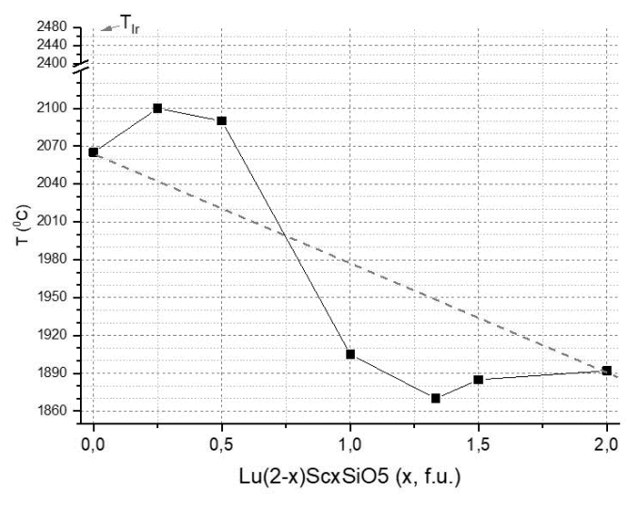
Fig. 1 Melting temperature of composition
Lu_{(2-x)}Sc_{x}SiO₅ (use PNG, TIF or JPG files)

Tables. Put the title above each table (Table 1). Use Times New Roman, 9 pt, single spacing. Keep formatting simple and units/significant figures consistent.
References. Include only necessary citations and provide complete bibliographic data in a consistent style (Author(s), Journal/Book, volume (year) page). Prefer accessible sources.
Acknowledgements are optional. If needed, add one short sentence on funding/projects/partners; do not include confidential information.
File preparation. Submit a .docx file and keep size reasonable (compress images if needed). Suggested name: RAREMET2026_Abstract_Surname_FirstAuthor.docx. Ensure nothing exceeds margins and the page limit.
Compliance. Submission confirms the material is publishable in the RAREMET‑2026 Book of Abstracts and approved by all co‑authors.
Do not leave unnecessary spaces between words.
– font type Times New Roman, 10 pt, single spacing;
– axes and legends should be in English;
– graphical images and photos should be in TIF format with minimum resolution of 600 and 300 dpi, respectively.
– do not use MS Word graphic editor to create images;
– avoid using grid lines in graphs;
– using numbers to mark graph lines is preferable;
– avoid using any formulas in graphs;
Tables should be formatted according to the following requirements:
– each table should titled;
– table font type Times New Roman, 9 pt, single spacing;
– tables can be page wide (spread over two text columns).
Acknowledgements are optional and should exceed 4 lines.
The abstract should be well written and double checked for any misprints and typos before submission.
We look forward to hosting you at RAREMET-2026 Congress in Moscow!

References:
- Z. Wang and A. Meijerink, J. Phys. Chem. Lett. 9 (2018) 1522.
- K. M. Kosyl, W. Paszkowicz, R. Minikayev, et al. Site-occupancy scheme in disordered Ca₃RE₂(BO₃)₄ a dependence on rare-earth (RE) ionic radius. Acta Cryst. 10 (2021) 382.
- J.M. Chalmers, P.R. Griffith, Eds. Handbook of Vibrational Spectroscopy. Vols. 1–5, John Wiley & Sons: London (2002).

